Nutritional and Compositional Analysis of Food Products(Arc-1)

Contents
1 Executive Summary 4
2 UI / Screen Design 4
2.1 Screen 1 – Signup / Login 4
2.1.1 Description 4
2.1.2 Screen Layout / Mockup 5
2.1.3 APIs 5
2.2 Screen 2 – Home Screen 6
2.2.1 Description 6
2.2.2 Screen Layout 6
2.2.3 APIs 7
2.3 Screen 3 – Scan Product Screen 7
2.3.1 Description 7
2.3.2 Screen Layout 8
2.3.3 APIs 9
2.4 Screen 4 – Product Information Display Screen 9
2.4.1 Description 9
2.4.2 Screen Layout 9
2.4.3 APIs 10
2.5 Screen 5 – Profile Screen 10
2.5.1 Description 10
2.5.2 Screen Layout 11
2.5.3 APIs 12
3 Database Design 12
3.1 User 12
3.2 Token 12
3.3 ScanHistory 12
3.4 Relationships 13
4 Backend / API design 13
4.1 API 1 14
4.2 API 2 15
4.3 API 3 16
4.4 API 4 17
4.5 API 5 18
5 Requirements Traceability 19

Executive Summary

The first iteration (Arc 1) of the Nutritional & Compositional Analysis Platform focuses on building a Minimum Viable Product (MVP) that enables users to easily access food product information through scanning of the ingredient list or barcode or through the search of the Product by name.
This version delivers the following core capabilities:
- User authentication (Signup/Login)
- Barcode scanning to fetch product data
- OCR-based ingredient extraction from labels
- Manual product search by name
- Display of ingredient list and nutritional information
- Storage of user scan history
The objective of this phase is to establish a functional and scalable foundation for future AI-driven features while ensuring a smooth and intuitive user experience

UI / Screen Design

Screen 1 – Signup / Login

Description
Allows users to register or Login securely to create a new account or use existing account respectively using their Email Id and Password to access personalized features.
Sign up – The new Registration of User requires the collection of inputs : Name, Email, Password
Log in – The existing Users can login to their accounts using the Email Id and the Password

Screen Layout / Mockup

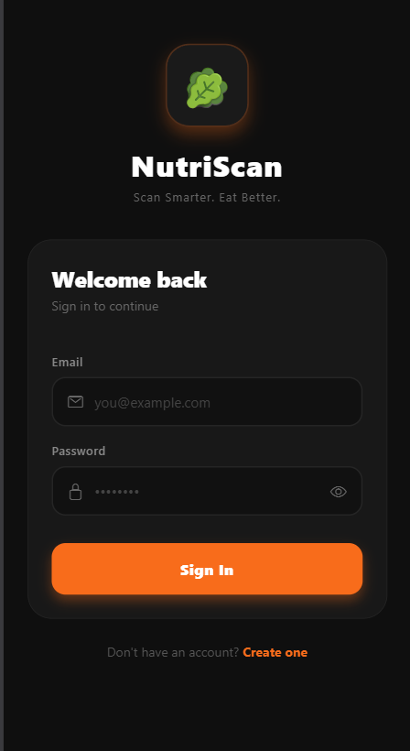
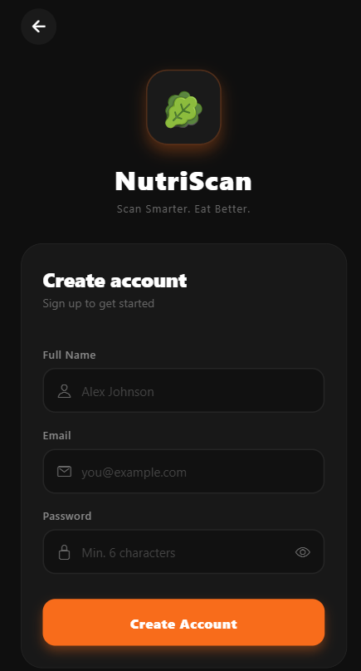
Sign up Log in

Components:
- Email input
- Password input
- Login / Signup buttons
- Forgot password option
Navigation:
- Login → Home Screen
- Signup → Onboarding → Home Screen

APIs
- POST /api/auth/register/
- POST /api/auth/login/

Screen 2 – Home Screen

Description
Main screen of the application where users can scan products or search manually. The screen provides a quick navigation to other pages like Profile, Scan History, Product Search Bar and Product Scanner.

Screen Layout
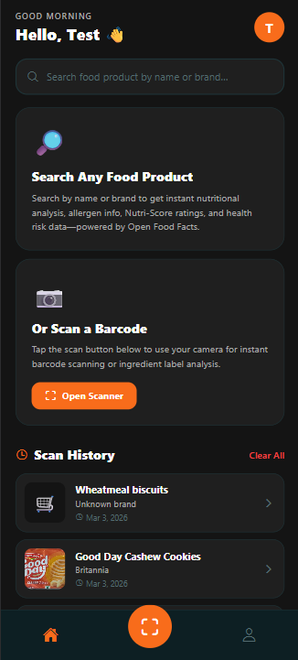
Components:
- User Profile Icon (Header)
- Product Search Bar (top)
- Scan Button : Barcode and Ingredient list Scanner
- Scan history
- Navbar (bottom) : Home, Scan, Profile

Navigation:
- Open Scanner (Button)→ Product Scan Screen
- Search → Product List → Product Detail Screen
- Home(Navbar) → Home Screen
- Scan(Navbar) → Scan Screen
- Profile(Navbar) → Profile Screen
- Scan History → Product List → Product Detail Screen

APIs
- GET /api/auth/profile/
- GET /api/products/search/
- GET /api/history/

Screen 3 – Scan Product Screen

Description
The Product scanning screen, where the user can use the device camera to scan the barcode or the ingredient list of a food product or the user can also upload a image from gallery. The image uploaded is scanned to extract information related to the product : Ingredient List and Nutritional Information. The user can also search for the product through the search bar by the name of the product.
The scanning of the images are categorized into two units :
- Barcode Scanning
- Ingredient List Scanning

Screen Layout
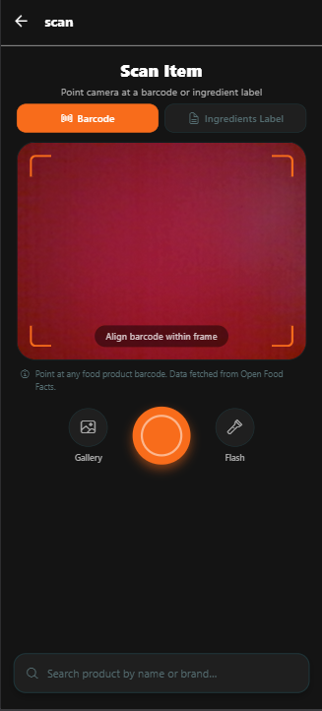
Components:
- Barcode Scanner
- Ingredient List Scanner
- Capture Area and Capture Tools : Shutter, Flash
- Gallery – Local Image Upload
- Search Bar – Product Search by name
Navigation:
- Open Scanner (Button)→ Product Scan Screen
- Search → Product List → Product Detail Screen
- Home(Navbar) → Home Screen
- Scan(Navbar) → Scan Screen
- Profile(Navbar) → Profile Screen
- Scan History → Product List → Product Detail Screen

APIs
- GET /api/products/search/
- GET /api/products/barcode/<barcode>/
- POST /api/products/analyze-label/
- POST /api/products/analyze-barcode/
- POST /api/history/

Screen 4 – Product Information Display Screen

Description
The Product Display Screen presents detailed information about a selected food product. It is accessed after scanning a product (barcode/OCR), searching for a product, or selecting an item from scan history.
This screen provides users with clear visibility into the product’s ingredients and nutritional composition, enabling informed decision-making.

Screen Layout
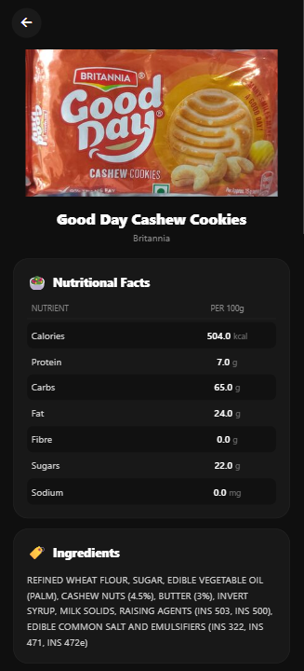
Components:
- Product Image
- Product Name
- Product Brand (optional)
- Nutritional Information of the Food Product
- Ingredient Section
Navigation:
- From Scan Screen → Product Display Screen
- From Search Results → Product Display Screen
- From Scan History → Product Display Screen
- Back Button → Previous Screen

APIs
- GET /api/products/barcode/<barcode>/ → Fetch product details via barcode
- POST /api/products/analyze-label/ → Fetch product details via OCR
- GET /api/products/search/ → Used when accessed via search
- POST /api/history/ → Save product to scan history

Screen 5 – Profile Screen

Description
The Profile Screen displays the user’s personal information and application settings. In the current version (Arc 1), most profile fields are read-only placeholders for future enhancements, while the primary functional feature available is theme switching (Dark Mode toggle).
This screen also allows the user to view account details and log out of the application.

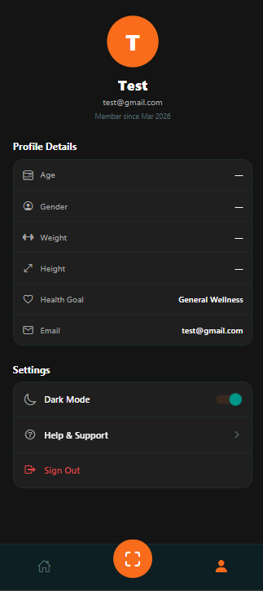
Screen Layout

Components:
- User Avatar (Initial-based Icon)
- User Name and Email
- Member Since - Information
- Profile Details Section (Age, Gender, Weight, Height, Health Goal, Email – Read Only)
- Dark Mode Toggle
- Help & Support Option (Placeholder)
- Sign Out Button
Navigation:
- Navbar → Profile → Profile Screen
- Sign Out → Login Screen
- Home (Navbar) → Home Screen
- Scan (Navbar) → Scan Screen

APIs
- GET /api/auth/profile/ → Fetch user profile details
- POST /api/auth/logout/ → Logout user

Database Design

Show the ER diagram or the Model Diagram from MySQL workbench.
If the diagram is not shown, describe all the tables – table names, attribute names, datatype, PK, FK etc.
Sample table definitions.
M – Mandatory, FK – Foreign key, UK – Unique key, PK – Primary Key

User
# | Name | Description | Datatype | Remarks
1 | id | Unique user ID | UUID / Integer | PK
2 | name | User name | Char(100)
3 | email | User email | Char(150) | Unique
4 | password | Hashed password | Char(256)
5 | created_at | Account creation date | DateTime

Token
# | Name | Description | Datatype | Remarks
1 | key | Authentication token | Char(40) | PK
2 | user_id | Linked user | FK → User
3 | created | Token creation time | DateTime

ScanHistory
# | Name | Description | Datatype | Remarks
1 | id | Unique ID | Integer | PK
2 | user_id | User reference | FK → User
3 | product_id | Product identifier (barcode/AI ID) | Char(50)
4 | name | Product name | Char(255)
5 | brand | Product brand | Char(150) | Optional
6 | image_url | Product image URL | Text | Optional
7 | scanned_at | Scan timestamp | DateTime | Indexed

Relationships
- User → ScanHistory → One-to-Many
- User → Token → One-to-One / One-to-Many

Backend / API design

Technology Layers
The backend system follows a layered architecture to ensure modularity and scalability:
- Presentation Layer (Frontend)
  - React Native mobile application
  - Handles UI, navigation, and API calls
- Application Layer (Backend)
  - Django + Django REST Framework
  - Handles business logic, authentication, and request processing
- Data Layer
  - PostgreSQL database
  - Stores user data and scan history
- External Services Layer
  - Open Food Facts API → Product data (barcode/search)
  - Google Gemini AI → Ingredient analysis (OCR)

API 1
Name: User Login API
Input Param / json:
{
"email": "string",
"password": "string"
}

Process:
- User enters email and password
- Backend validates credentials
- If valid → generate authentication token
- Return token and user details
Error Processing:
- 401 → Invalid credentials
- 400 → Missing fields
- 500 → Server error
Response:
{
"token": "abc123...",
"user": {
"id": 1,
"name": "User Name",
"email": "user@email.com"
}
}

API 2
Name: Product Search API
Input Param / json:
{
"q": "product name",
"page": 1,
"page_size": 20
}

Process:
- User enters product name
- Backend calls Open Food Facts API
- If no results → fallback to Gemini AI
- Normalize data
- Return product list
Error Processing:
- 400 → Missing query
- 401 → Unauthorized
- 502 → External API failure
- 500 → Server error
Response:
{
"count": 5,
"products": [
{
"id": "string",
"name": "Product Name",
"brand": "Brand",
"image_url": "string"
}
] }

API 3
Name: Product Fetch by Barcode API
Input Param / json:
{
"barcode": "string"
}
Process:
- User scans barcode
- Backend queries Open Food Facts
- Retrieve product details
- Return normalized data
Error Processing:
- 404 → Product not found
- 502 → External API error
- 500 → Server error
Response:
{
"id": "8901058002157",
"name": "Product Name",
"brand": "Brand",
"ingredients": "string",
"nutrients_100g": {
"energy_kcal": 100,
"proteins": 5,
"carbohydrates": 20,
"fat": 10
}
}

API 4
Name: OCR Ingredient Scan API
Input Param / json:
{
"image": "base64-encoded string"
}
Process:
- User uploads product label image
- Backend sends image to Gemini AI
- Extract ingredients and nutrition data
- Return structured product data
Error Processing:
- 400 → No image provided
- 501 → AI service not configured
- 500 → Processing error
Response:
{
"id": "generated_id",
"name": "Detected Product",
"ingredients": "string",
"nutrients_100g": {
"energy_kcal": 120
}
}

API 5
Name: Scan History API
Input Param / json:
{
"product_id": "string",
"name": "string",
"brand": "string",
"image_url": "string"
}
Process:
- Product is scanned/searched
- Backend stores product details in history
- If already exists → update timestamp
- Return success response
Error Processing:
- 400 → Invalid data
- 401 → Unauthorized
- 500 → Server error
Response:
{
"message": "Saved to history"
}

Requirements Traceability

# | Requirements | Design | Code
1 | User Registration and Login | Section 2.1 | Sec 4.1
2 | User Profile Viewing | Section 2.5 (Profile Screen) | Sec 4.1
3 | Product Search by Name | Section 2.2 , 2.3 (Home / Scan Screen) | Sec 4.2
4 | Barcode Scanning for Product | Section 2.3 (Scan Screen) | Sec 4.3
5 | Ingredient List Scanning (OCR) | Section 2.3 (Scan Screen) | Sec 4.4
6 | Display Product Details (Ingredients & Nutrition) | Section 2.4 (Product Display Screen) | Sec 4.3, 4.4
7 | Scan History Storage | Section 2.2 (Scan / Product Flow) | Sec 4.5
8 | View Scan History | Section 2.2 (Home Screen) | Sec 4.5
9 | User Logout | Section 2.5 (Profile Screen) | Sec 4.1

